Analysis Document

Individual Track



# Content

Table of Contents

Content 1

Introduction: 2

References 3

Project Planning 4

Versioning Table 5

Project Goals 6

Project Goals: 6

Product Backlog 7

- User Stories: 7

- Acceptance Criteria 8

# Introduction:

The Software Project that is going to be developed during this semester, is a Web Application that is going to serve as a booking system to book water sports lessons primarily kitesurfing lessons.

The web app will allow to the admins to manage the kite lessons so that the customers can book from them.

This document provides an initial overview about the purpose of the web app namely the what, why and how to bring the reader closer and gives a good understanding of what is expected to be built by the end of the semester.

Disclaimer:

The features that are going to be presented in the document and subsequent project documentations are subject to a change depending on the semester setup, material, learning outcomes and finally teachers and coaches’ decisions/suggestions throughout the semester.

# References

Git Link:

[Chbiki,Ismail I. / Individual Track S3 · GitLab (fhict.nl)](https://git.fhict.nl/I479364/individual-track-s3)

Jira Link: (invitations are sent to all the teachers)

[IT board - Roadmap - Jira (atlassian.net)](https://ismailchbiki.atlassian.net/jira/software/c/projects/IT/boards/5/roadmap)

# Project Planning

The project planning process that will be applied for the built of this project is agile as an iterative approach to the project management and the software development.

The software tool to be used to help the management of the project work flow is *Jira Software*

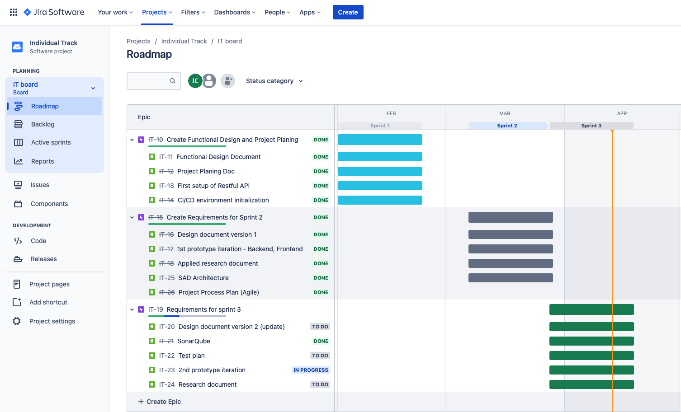

Jira Link

# Versioning Table

|  |  |  |  |  |
| --- | --- | --- | --- | --- |
| Sprint | Release | Name | Release Date | Updates |
| 1 | 0.0.1 | Semester Startup Release | 25.02.2022 | - Environment setup |
| 2 | 0.0.2 | Basic React frontend to the API | 25.03.2022 | - Basic frontend API calls |
| 3 | 0.0.3 | Unit + Integration test | 14.04.2022 | - Unit and Integration testing added |

# Project Goals

## Project Goals:

* This project should help clients access a Web App and learn from which about the different kite lessons types and the learning process and requirements.
* The web app owners should be able to manage the kite lessons on the website.
* It should allow potential customers to place a reservation and have a kite lesson at a given scheduled time and location.

# Product Backlog

## User Stories:

* *(Acceptance Criteria in the next Page)*

|  |  |  |  |  |  |  |  |  |
| --- | --- | --- | --- | --- | --- | --- | --- | --- |
| Order | Story ID | Estimate | Sprint | User Type | Story | Story Type | Priority | Status |
| 1 | A-01 |  | 2 | Client | * I want to be able to view available kite lessons So that I can get to choose what suits me best | Story | High | Done |
| 2 | A-02 |  | 2 | Client | * I want to be able to place a reservation for a kite lesson, so that I can learn how to kite | Story | Medium | In progress |
| 3 | A-03 |  | 2 | Client | * I want to be able to create an account, so that I can become a member to the website | Story | Low | To do |
| 4 | A-04 |  | 2 | Client | * I want to be able to sign in to my account, so that I can view my past bookings and kiting level | Story | Low | To do |
| 5 | A-05 |  | 2/3 | Owner | * I want to be able to create instructors so that clients can reserve an instructor | Story | Low | To do |
|  |  |  |  |  |  |  |  |  |

## Acceptance Criteria

* User Story ID: A-01

As a client,

I want to be able to view available kite lessons

So that I can get to choose what suits me best

* Acceptance Criteria:
* Available lessons are displayed when requested:

Lesson type (private, semi-private, group);

Time slots in a day (3 slots – 10am->12am, 2pm->4pm, 4pm->6pm);

Experience level (Beginner, Intermediate, Advanced)

* User Story ID: A-02

As a client,

I want to be able to place a reservation for a kite lesson

So that I can learn how to kite

* Acceptance Criteria:
* Available lessons are displayed when requested:

Lesson type (private, semi-private, group);

Time slots in a day (3 slots – 10am->12am, 2pm->4pm, 4pm->6pm);

Experience level (Beginner, Intermediate, Advanced)

* I can select my preferences to make a booking
* Possibility to fill in personal details (provide name, phone, email)
* All booking information is stored
* An email is sent to the customer mail box
* User Story ID: A-03

As a client,

I want to be able to create an account

So that I can become a member to the website

* Acceptance Criteria:
* Email, username, password fields must be filled with the expected correct data
* I cannot create an account with an existing username or email
* Ability to activate my account via a sent link to my mail box
* My dashboard/account is displayed via the link in my mail box
* User Story ID: A-04

As a client member,

I want to be able to sign in to my account

So that I can join the online discussion by the website members

* Acceptance Criteria:
* username, password fields must be filled with the expected correct data
* Dashboard is displayed
* Dashboard is not displayed in case of incorrect credentials
* Dashboard is not displayed in case of a missing approval from the link in the email
* User Story ID: A-05

As an owner,

I want to be able to create instructors so that clients can reserve an instructor

* Acceptance Criteria:
* I can create an instructor by providing name, email, password, and spoken languages
* I cannot create an instructor with duplicate name or email
* New instructor is created successfully is displayed

End